UNITED STATES
SECURITIES AND EXCHANGE COMMISSION
Washington, D.C. 20549
SCHEDULE 14A
Proxy Statement Pursuant to Section 14(a) of the
Securities Exchange Act of 1934
(Amendment No. )
Filed by the Registrant |  |  | ☒
Filed by a Party other than the Registrant |  |  | ☐
Check the appropriate box:
☐ | Preliminary Proxy Statement
☐ | Confidential, for Use of the Commission Only (as permitted by Rule 14a-6(e)(2))
☐ | Definitive Proxy Statement
☒ | Definitive Additional Materials
☐ | Soliciting Material under §240.14a-12
MoonLake Immunotherapeutics
(Name of Registrant as Specified In Its Charter)
(Name of Person(s) Filing Proxy Statement if other than the Registrant)
Payment of Filing Fee (Check all boxes that apply):
☒ | No fee required.
☐ | Fee paid previously with preliminary materials.
☐ | Fee computed on table in exhibit required by Item 25(b) per Exchange Act Rules 14a-6(i)(1) and 0-11.

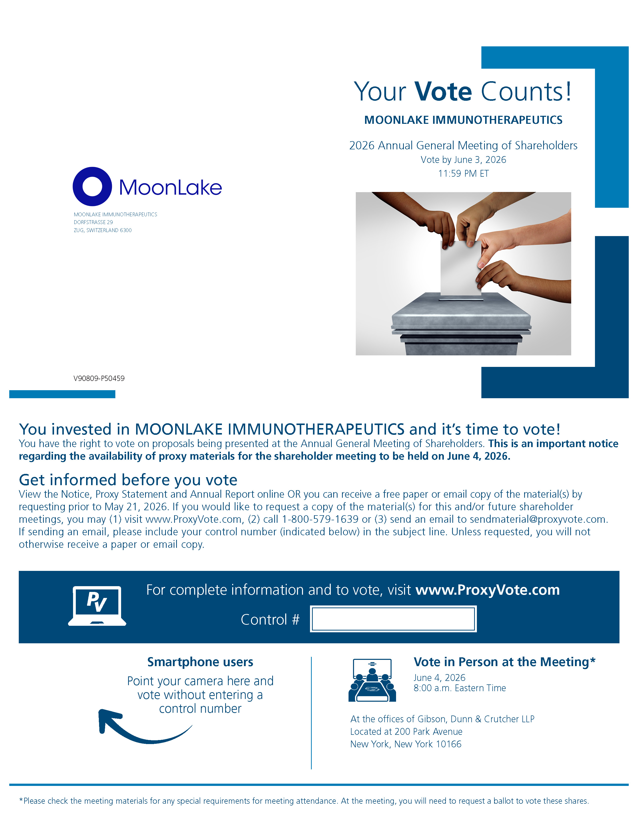
Your Vote Counts! *Please check the meeting materials for any special requirements for meeting attendance. At the meeting, you will need to request a ballot to vote these shares. Smartphone users Point your camera here and vote without entering a control number For complete information and to vote, visit www.ProxyVote.com Control # V90809-P50459 MOONLAKE IMMUNOTHERAPEUTICS DORFSTRASSE 29 ZUG, SWITZERLAND 6300 MOONLAKE IMMUNOTHERAPEUTICS 2026 Annual General Meeting of Shareholders Vote by June 3, 2026 11:59 PM ET You invested in MOONLAKE IMMUNOTHERAPEUTICS and it’s time to vote! You have the right to vote on proposals being presented at the Annual General Meeting of Shareholders. This is an important notice regarding the availability of proxy materials for the shareholder meeting to be held on June 4, 2026. Get informed before you vote View the Notice, Proxy Statement and Annual Report online OR you can receive a free paper or email copy of the material(s) by requesting prior to May 21, 2026. If you would like to request a copy of the material(s) for this and/or future shareholder meetings, you may (1) visit www.ProxyVote.com, (2) call 1-800-579-1639 or (3) send an email to sendmaterial@proxyvote.com. If sending an email, please include your control number (indicated below) in the subject line. Unless requested, you will not otherwise receive a paper or email copy. Vote in Person at the Meeting* June 4, 2026 8:00 a.m. Eastern Time At the offices of Gibson, Dunn & Crutcher LLP Located at 200 Park Avenue New York, New York 10166

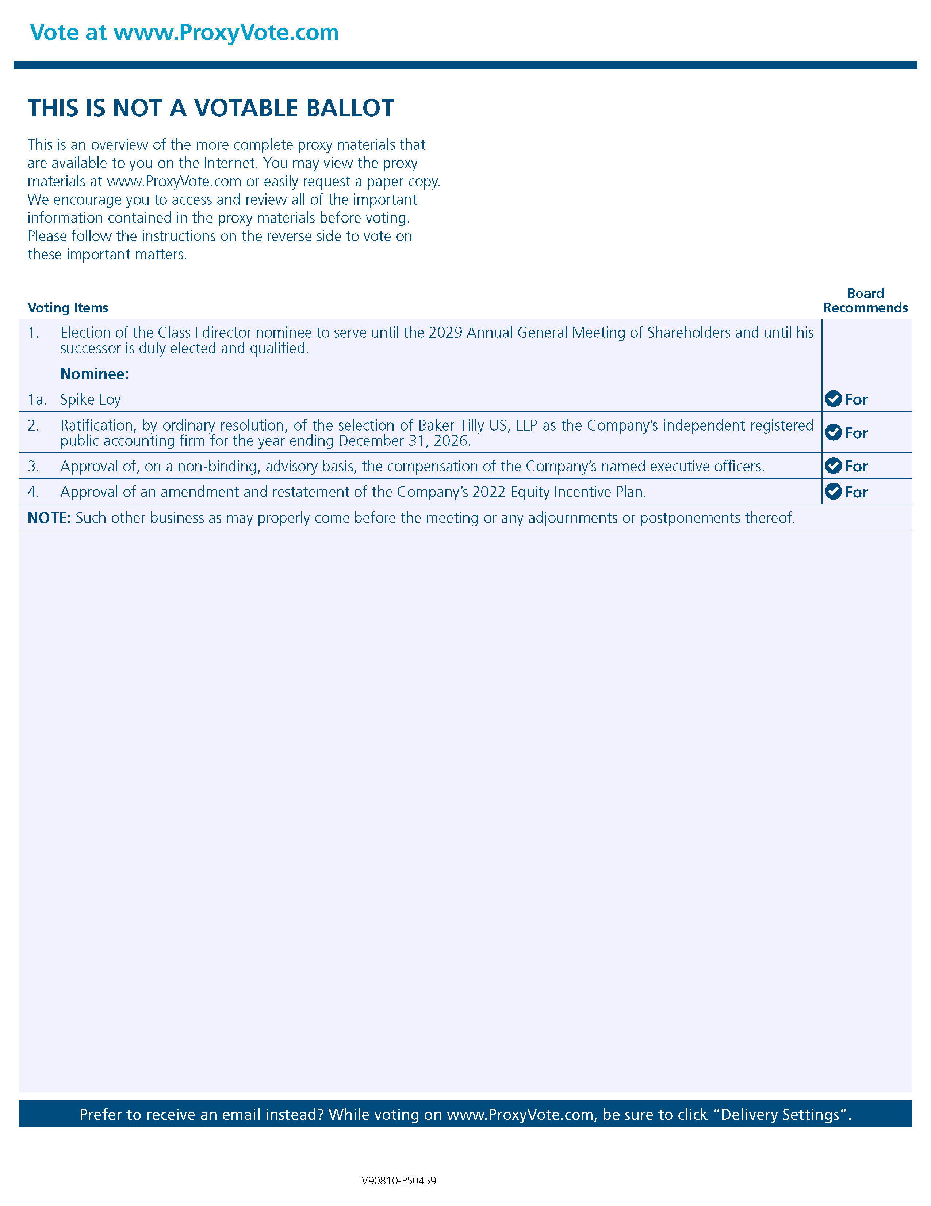
Vote at www.ProxyVote.com THIS IS NOT A VOTABLE BALLOT This is an overview of the more complete proxy materials that are available to you on the Internet. You may view the proxy materials at www.ProxyVote.com or easily request a paper copy. We encourage you to access and review all of the important information contained in the proxy materials before voting. Please follow the instructions on the reverse side to vote on these important matters. Prefer to receive an email instead? While voting on www.ProxyVote.com, be sure to click “Delivery Settings”. V90810-P50459 1. Election of the Class I director nominee to serve until the 2029 Annual General Meeting of Shareholders and until his successor is duly elected and qualified. For Nominee: 1a. Spike Loy 2. Ratification, by ordinary resolution, of the selection of Baker Tilly US, LLP as the Company’s independent registered public accounting firm for the year ending December 31, 2026. For 3. Approval of, on a non-binding, advisory basis, the compensation of the Company’s named executive officers. For 4. Approval of an amendment and restatement of the Company’s 2022 Equity Incentive Plan. For NOTE: Such other business as may properly come before the meeting or any adjournments or postponements thereof. Voting Items Board Recommends

